Depending on the program’s state, certain buttons will be enabled/disabled

Inventory.txt: read by the program when a user makes a selection

Transactions.txt: data is output to this file when user makes a transaction

**Need to comment the source code with the following:**

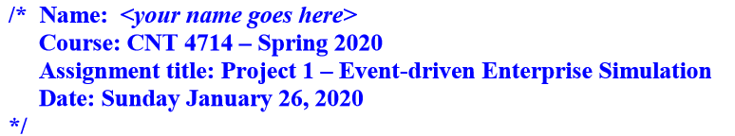

Modes

Process Order:

* “if not maxed out, and not processed, enable

Confirm Order:

* If not maxed out, and processed, enable

viewOrder: enable only if totally filled to max

finishOrder: enable only if totally filled to max

new order and exit: always enabled